**Ideation Phase**

**Brainstorm & Idea Prioritization Template**

|  |  |
| --- | --- |
| Date | 24 October 2022 |
| Team ID | PNT2022TMID15139 |
| Project Name | Smart Farmer - IoT Enabled Smart Farming Application |
| Maximum Marks | 4 Marks |

**Brainstorm & Idea Prioritization Template:**

**Team Gathering, Collaboration and Select the Problem Statement:**

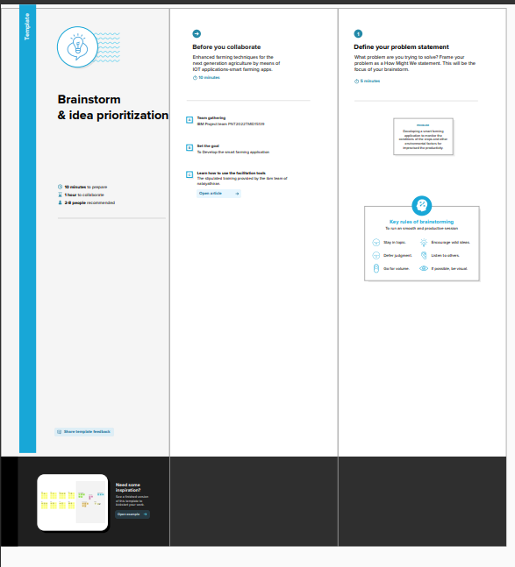

**Brainstorm, Idea Listing and Grouping:**

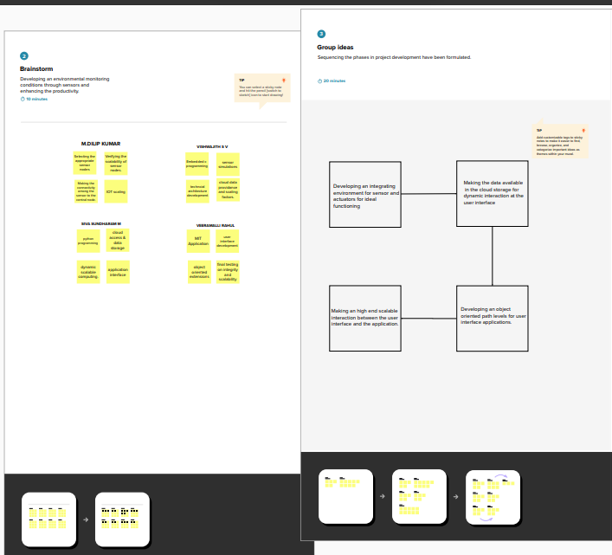

**Idea Prioritization:**

